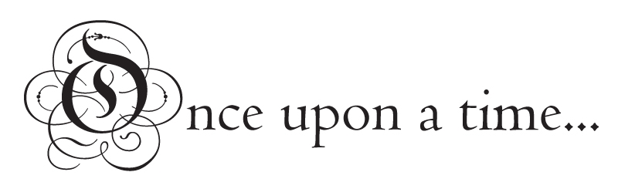

**Maths**

**Money:** Recognise and use symbols £ and p, find different combinations of coins to make the same value, solve problems.

**Multiplication and Division:**2, 5 and 10 times tables, solve problems.

**Statistics:**Tables, tally charts, pictograms, ask and answer simple questions about data.

**Properties of shape:**Identify and describe properties of 2D and 3D shapes, compare and sort common 2D and 3D shapes and everyday objects.

**Fractions:**Recognise, find and name thirds and quarters, write simple fractions and recognise equivalent fractions

**Length and Height:**Estimate and measure in standard units, compare and order measurements.

**Daily Fluency lessons**

**Art and DT**

We will transform our classroom into Fairytale land using a variety of media.

Make Gingerbread Men.

Construct houses and castles

Design and make shields.

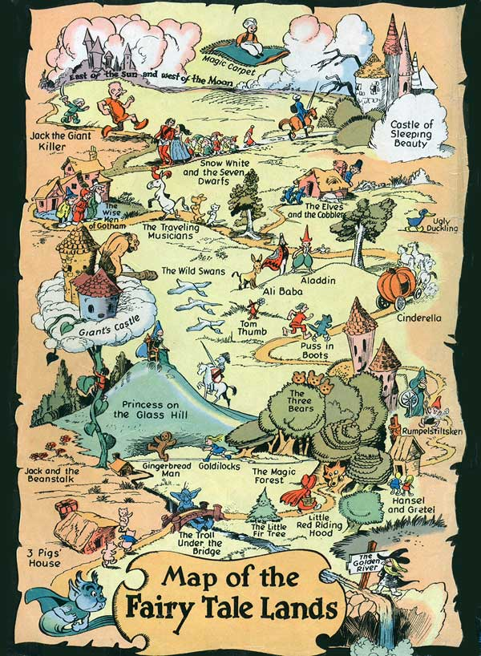

**Geography**

We will learn create maps of Fairytale Land and compare these to our local area. We will describe physical and human features, use aerial photos and simple compass directions.

**PSHE**

We will talk about kindness and friendships.

We will think about how events in the media make us feel.

**History**

We will learn about historical events, buildings and our monarchy.

We will visit Warwick castle and learn about it’s history and study William the Conqueror.

**Science**

We will investigate which materials are most suitable for building a house for the 3 little pigs

We will plant beanstalks and investigate what plants need to grow well.

**English**

We will read a range of Traditional Tales including The Gingerbread Man, Little Red Riding Hood and Jack and the Beanstalk. We will also look at information texts on castles.

We will write instructions, innovate stories, character descriptions, invitations, letters and a recount.

We will concentrate on using the correct punctuation in our writing including full stops, capital letters, question marks and exclamation marks. We will also concentrate on correct letter formation and accurate spelling.

Daily phonics lessons.

**PE**

Fairytale Dance

**Computing**

Bee-bot maps to recreate journeys of story characters.

**Music**

‘I wanna play in a band’

**RE**

Who is a Muslim and how do they live?

Why does Easter matter to Christians?