11th January 2018
Dear Parents/Carers,
Happy New Year! The children have returned to school ready to learn and are enthusiastic for the term ahead. We have a very busy term and lots of hard work to do in preparation for SAT’s in the Summer Term.
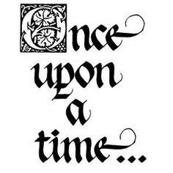
This term our theme is ‘Once Upon a Time’. We will be helping the Friendly Dragon rebuild Fairytale land by reading and learning about lots of Traditional Tales including The Gingerbread Man, Little Red Riding Hood and Jack and the Beanstalk. We have been busy transforming our class into Fairytale land by creating lots of different settings including a castle and a cottage.
In our theme work, we will be imitating and inventing our own Traditional Tales. We will investigate the best materials for building a house for the three little pigs, grow our own beanstalks and learn about castles. In the second half term we will be visiting Warwick Castle.

We will have PE on Thursday. Last term there were a number of children who weren’t able to participate in PE lessons due to them not having a PE kit in school, please ensure PE kits are in school on the appropriate days. Please send your child with a water bottle and healthy snack each day. There will also be fruit and vegetable snacks available in class.

Your support at home with reading and spellings is really important in helping your child improve in each of these subjects. Please try to find some time each day to complete some homework with your child. Reading books will be changed twice a week. Please try to read with your child throughout the week following the guidelines in the reading record. Comprehension and understanding of reading will be a focus for our reading this term. Spellings will be sent home each Thursday and should be returned the following Thursday. Please ensure the children are practising these throughout the week.

If you have any questions or concerns, please do not hesitate to come and speak to me or a member of the Year 2 team.

Miss Vickers Mrs Brixey Mrs Lordan

